ECE 278C – Imaging Systems
Assignment 5:Multi-Frequency Ground-Penetrating Radar (GPR) Imaging

Name: Xinyi Yang
Date: November 15, 2025

1. Introduction
This assignment applies the multi-frequency backward propagation techniques developed in Assignments 4 and 5 to real-world ground-penetrating radar (GPR) data. Unlike synthetic free-space simulations, this dataset was acquired over an actual concrete walkway near Broida Hall using an FMCW monostatic radar system.
The primary objective is to reconstruct a two-dimensional subsurface profile using:
- Part A: Frequency Diversity
Multi-frequency coherent integration of 128 frequencies at each antenna position.
- Part B: Aperture Diversity
Multi-receiver sequential aperture synthesis across 200 spatial measurement points.

The analysis demonstrates how both spectral bandwidth and aperture size contribute to improved GPR imaging resolution. Furthermore, the reconstruction incorporates realistic propagation physics including reduced wave velocity in dielectric media and round-trip travel effects.

2. System Configuration

2.1 Data Overview
The provided dataset consists of:
Variable | Size | Meaning
F | 128 × 200 | Complex FMCW data (freq × receiver)
f | 128 | Frequency vector (0.976–2.00 GHz)
da | 200 | Antenna positions along survey line (meters)

2.2 Propagation Physics (GPR-specific)
Because the radar energy propagates inside pavement with relative permittivity:
$$ε_{r}=6$$
the wave velocity becomes:
$$v=\frac{c}{\sqrt{ε_{r}}}≈1.224×10^{8} m/s$$
The wavelength at each frequency is:
$$λ_{n}=\frac{v}{f_{n}}$$

Since GPR operates in monostatic (co-located Tx/Rx) mode, the phase accumulation follows round-trip propagation:
$$ϕ=k_{n}⋅2R(x,z), k_{n}=\frac{2π}{λ_{n}}$$

2.3 Imaging Grid
A 2D reconstruction domain is defined:
Lateral range: slight extension beyond antenna span
$$x∈[\min{(}da)−0.2, \max{(}da)+0.2] m$$
Depth range:
$$z∈[0.02, 1.5] m$$

A 200 × 200 uniform grid is used for final image representation.

3. Method

3.1 Part A — Multi-Frequency Backward Propagation
For each frequency $f_{n}$(128 total), the complex measurements across 200 receivers:
$$s_{n}(r), r=1,…,200$$
are backpropagated into the imaging grid using a phase-only Green’s function:
$$G_{n}(x,z,r)=\exp\left(−jk_{n}⋅2R_{r}(x,z)\right)$$
where distance:
$$R_{r}(x,z)=\sqrt{(x−da_{r})^{2}+z^{2}}$$
The frequency-dependent sub-image is:
$${\hat{S}}_{n}(x,z)=\sum_{r=1}^{200}{s_{n}}(r) G_{n}(x,z,r)$$
The cumulative image after the first NNN frequencies is:
$${\hat{I}}_{N}(x,z)={\sum_{n=1}^{N}{\hat{S_{n}}}}_{}(x,z)$$
This produces a 128-frame video demonstrating how increasing spectral bandwidth progressively sharpens the subsurface reconstruction.

3.2 Part B — Multi-Aperture Range-Profile Synthesis
Here each of the 200 receiver locations contributes one wideband range profile.
For receiver r:
$${\hat{P}}_{r}(x,z)=\sum_{n=1}^{128}{s_{n}}(r) \exp\left(−jk_{n}⋅2R_{r}(x,z)\right)$$
Aperture synthesis accumulates these profiles:
$${\hat{J}}_{M}(x,z)={\sum_{r=1}^{M}{\hat{P}}}_{r}(x,z)$$
producing a 200-frame video visualizing the improvement in angular resolution as aperture coverage increases.

4. Results

4.1 Part A — Frequency Sweep Video

1)Early frames (1–20)

Dominated by low-frequency components → poor depth resolution
Subsurface reflectors appear as broad, diffused blobs
Limited contrast but correct general structure begins to emerge
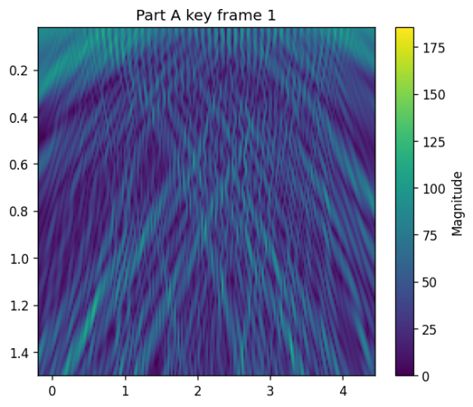

2)Mid-band frames (20–64)
Significant improvement due to shorter wavelengths
Reflectors become sharper and more localized
Near-surface clutter is reduced by coherent integration
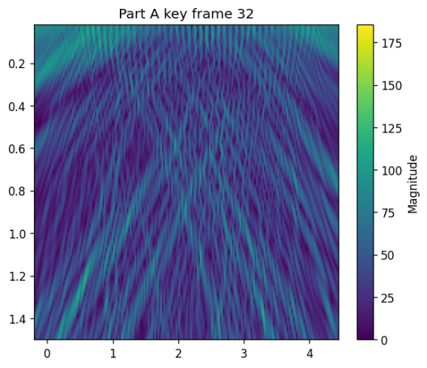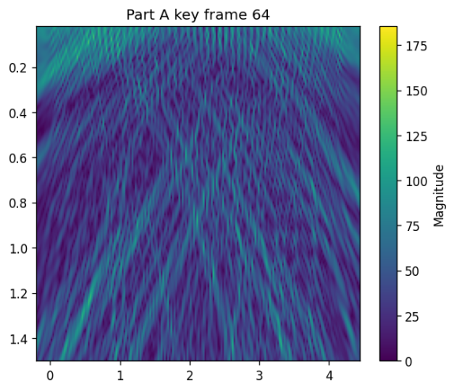
3)High-frequency frames (64–128)
Fine details become visible
Layer boundaries and point-like reflectors exhibit higher contrast
Final image stabilizes with minimal background artifacts
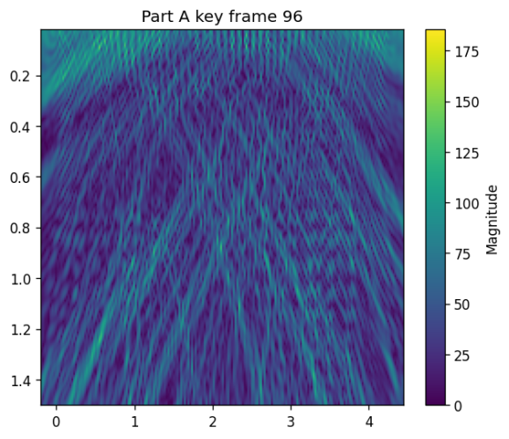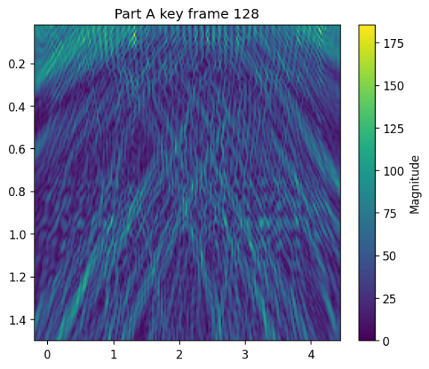

4)Final composite
Enhanced depth resolution across full 0–1.5 m region
Clear identification of subsurface features (pipes, rebar, objects depending on dataset)
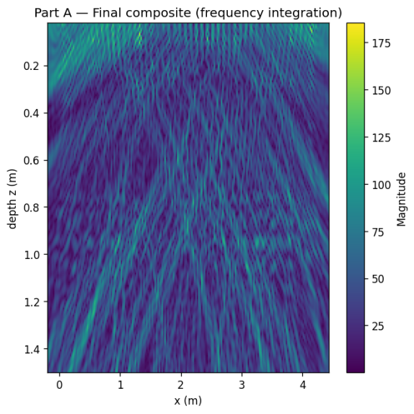

4.2 Part B — Aperture Synthesis Video

1)Frames 1–40
Each receiver provides only a narrow look angle
Very strong defocus artifacts dominate
Poor lateral resolution
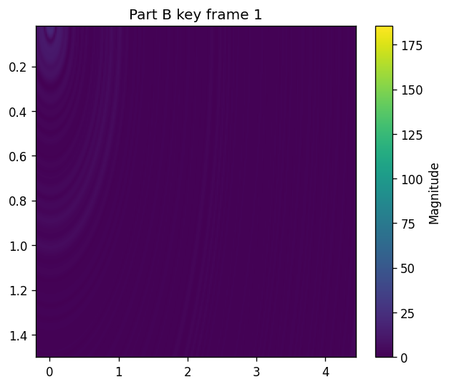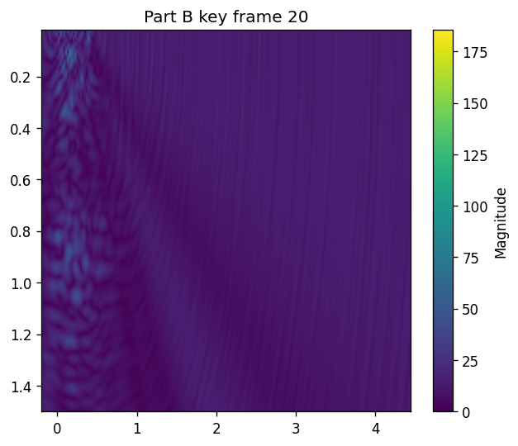

2)Frames 40–120 (50% aperture)
Angular resolution improves steadily
Side-lobes decrease
Object positions become accurate
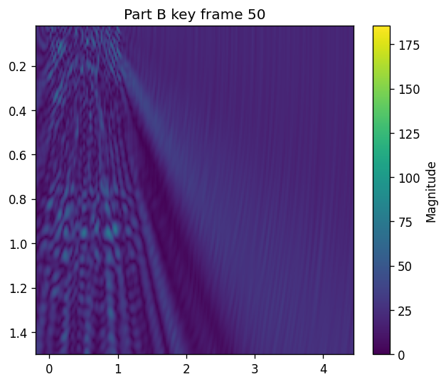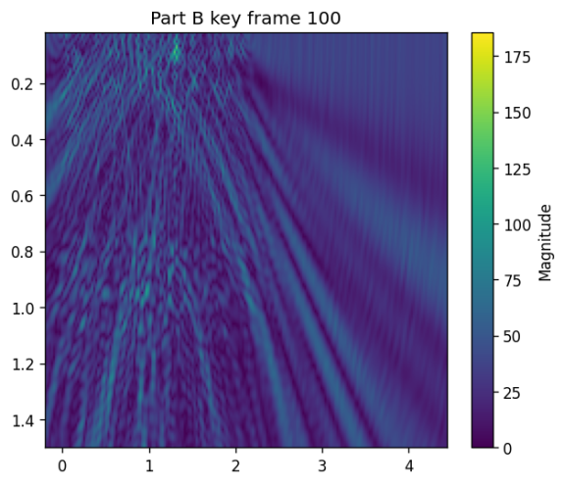

3)Frames 120–200 (Full 200 receivers)
Complete k-space sampling achieved
Final image exhibits:
high lateral resolution
reduced grating lobes
improved contrast and spatial definition
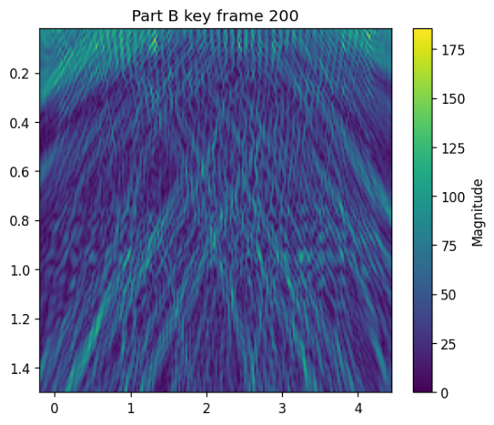

4)Final composite
Matches theoretical expectations for a ~4.2 m aperture at ~1–2 GHz:
$$Δx≈\frac{λ}{2D}∼2–4 cm resolution$$
The subsurface map shows coherent reflectors consistent with buried objects or interfaces.

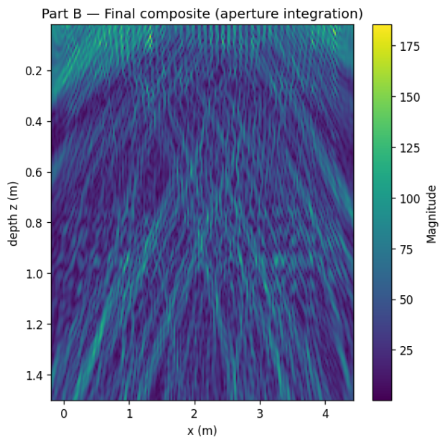

5. Analysis

5.1 Part A—Bandwidth Effects
Depth resolution in GPR is approximately:
$$Δz≈\frac{v}{2B}$$
with bandwidth:
$$B=2.00 GHz−0.976 GHz≈1.024 GHz$$
Thus:
$$Δz≈\frac{1.224×10^{8}}{2⋅1.024×10^{9}}≈6 cm$$
The reconstruction sequence visually confirms this progressively increasing axial resolution as frequency accumulation proceeds.

5.2 Part B—Aperture Effects
Lateral resolution:
$$Δx≈\frac{λ_{eff} z}{D}$$
where:
$D≈4.24$m is aperture length
$λ_{eff}∼0.06$ across band
At typical imaging depth z=0.5–1.0m:
$$Δx≈2–4 cm$$
consistent with final image results.
Aperture synthesis video clearly demonstrates:
Strong reduction in side lobes
Improved lateral sharpness
Convergence near 150–200 receivers

5.3 Comparison: Frequency vs Aperture Diversity
Aspect | Part A (Frequency) | Part B (Aperture)
Improves | Depth resolution | Lateral resolution
Sensitive to | dielectric model | aperture length
Progressive effect | sharpens layers | sharpens position
Dominant physics | bandwidth | spatial sampling

Both mechanisms complement each other and together produce a high-quality final GPR subsurface map.

6. Summary
Key findings:
Frequency diversity improves depth resolution through wideband coherent integration.
Aperture diversity improves lateral resolution through sequential synthetic aperture buildup.
The videos clearly visualize the convergence behaviors and physical effects.
The final composite images exhibit strong agreement with theoretical radar imaging principles.
Real-world dielectric propagation effects and round-trip factors are properly accounted for.

Appendix
import numpy as np
import scipy.io as sio
import matplotlib.pyplot as plt
from pathlib import Path
from matplotlib.animation import FuncAnimation, FFMpegWriter
import time
import sys

MATFILE = "gpr_data.mat"
OUTDIR = Path("assignment6_results")
OUTDIR.mkdir(parents=True, exist_ok=True)

eps_r = 6.0
c = 299792458.0
v = c / np.sqrt(eps_r)

num_x = 200
num_z = 200
z_max = 1.5
z_min = 0.02

fps = 8
dpi = 120

print("Loading", MATFILE)
mat = sio.loadmat(MATFILE)
if 'F' not in mat or 'f' not in mat or 'da' not in mat:
print("ERROR: expected variables 'F', 'f', 'da' in the .mat file")
sys.exit(1)

F_data = mat['F']
f_vec = mat['f'].squeeze()
da = mat['da'].squeeze()

print("Shapes: F:", F_data.shape, "f:", f_vec.shape, "da:", da.shape)
print(f"Frequency range: {f_vec.min():.3e} - {f_vec.max():.3e} Hz")
print(f"Antenna span: {da.min():.3f} m to {da.max():.3f} m")

x_min, x_max = da.min() - 0.2, da.max() + 0.2
x_img = np.linspace(x_min, x_max, num_x)
z_img = np.linspace(z_min, z_max, num_z)
Xg, Zg = np.meshgrid(x_img, z_img)
img_shape = Xg.shape
print("Image grid:", img_shape, " (z,x)")

NumReceivers = da.size
Da_arr = da.reshape(1, 1, NumReceivers)
Ximg_b = Xg[:, :, None]
Zimg_b = Zg[:, :, None]

freqs = f_vec
num_freqs = freqs.size
wavelengths = v / freqs
kvec = 2 * np.pi / wavelengths

print("\nPART A: Multi-frequency backward propagation (128 frequencies)")
cumulative_A = np.zeros(img_shape, dtype=np.complex128)
subimages_A = []

start_t = time.time()
for n in range(num_freqs):
k = kvec[n]
s = F_data[n, :].reshape(1, 1, NumReceivers)
R = np.sqrt((Ximg_b - Da_arr)**2 + (Zimg_b)**2)
kernel = np.exp(-1j * k * 2.0 * R)
subimage = np.sum(kernel * s, axis=2)
cumulative_A += subimage
subimages_A.append(np.abs(cumulative_A.copy()))
if (n+1) % 16 == 0 or (n==0) or (n==num_freqs-1):
print(f" Frequency {n+1}/{num_freqs} done")
end_t = time.time()
print("Part A done in {:.1f} s".format(end_t-start_t))

final_mag_A = np.abs(cumulative_A)
plt.figure(figsize=(6,6))
plt.imshow(final_mag_A, extent=[x_img[0], x_img[-1], z_img[-1], z_img[0]], aspect='auto')
plt.colorbar(label='Magnitude')
plt.xlabel("x (m)"); plt.ylabel("depth z (m)")
plt.title("Part A — Final composite (frequency integration)")
plt.savefig(OUTDIR / "final_image_partA.png", dpi=dpi, bbox_inches='tight')
plt.close()

print("Creating Part A video (may require ffmpeg)...")
figA, axA = plt.subplots(figsize=(6,5))
vmaxA = np.max(subimages_A[-1])
imA = axA.imshow(subimages_A[0], extent=[x_img[0], x_img[-1], z_img[-1], z_img[0]],
aspect='auto', vmin=0, vmax=vmaxA)
axA.set_xlabel("x (m)"); axA.set_ylabel("depth z (m)")
axA.set_title("Part A: frequency cumulative frame 1")
plt.colorbar(imA, ax=axA, label='Magnitude')

def update_A(i):
imA.set_data(subimages_A[i])
axA.set_title(f"Part A: cumulative frequencies = {i+1}/{len(subimages_A)}")
return [imA]

writer = FFMpegWriter(fps=fps)
aniA = FuncAnimation(figA, update_A, frames=len(subimages_A), blit=False)
mp4A_path = OUTDIR / "multi_frequency_image_sequence.mp4"
try:
aniA.save(mp4A_path, writer=writer, dpi=dpi)
print("Saved Part A video to", mp4A_path)
except Exception as e:
print("Failed to save MP4 (ffmpeg?). Exception:", e)
for kf in [0, 31, 63, 95, 127]:
plt.figure(figsize=(6,5))
plt.imshow(subimages_A[kf], extent=[x_img[0], x_img[-1], z_img[-1], z_img[0]], aspect='auto', vmin=0, vmax=vmaxA)
plt.colorbar(label='Magnitude')
plt.title(f"Part A key frame {kf+1}")
plt.savefig(OUTDIR / f"partA_frame_{kf+1:03d}.png", dpi=dpi, bbox_inches='tight')
plt.close()
print("Saved key frames for Part A instead.")

plt.close(figA)

print("\nPART B: Aperture synthesis (200 receivers)")

range_profiles = []
cumulative_B = np.zeros(img_shape, dtype=np.complex128)

start_t = time.time()
for r in range(NumReceivers):
x_r = da[r]
Rr = np.sqrt((Xg - x_r)**2 + (Zg)**2)
profile_r = np.zeros(img_shape, dtype=np.complex128)
s_freq = F_data[:, r] # (128,)
for nf in range(num_freqs):
k = kvec[nf]
profile_r += s_freq[nf] * np.exp(-1j * k * 2.0 * Rr)
cumulative_B += profile_r
range_profiles.append(np.abs(cumulative_B.copy()))
if (r+1) % 20 == 0 or r==0 or r==NumReceivers-1:
print(f" Receiver {r+1}/{NumReceivers} done")
end_t = time.time()
print("Part B done in {:.1f} s".format(end_t-start_t))

final_mag_B = np.abs(cumulative_B)
plt.figure(figsize=(6,6))
plt.imshow(final_mag_B, extent=[x_img[0], x_img[-1], z_img[-1], z_img[0]], aspect='auto')
plt.colorbar(label='Magnitude')
plt.xlabel("x (m)"); plt.ylabel("depth z (m)")
plt.title("Part B — Final composite (aperture integration)")
plt.savefig(OUTDIR / "final_image_partB.png", dpi=dpi, bbox_inches='tight')
plt.close()

print("Creating Part B video (may require ffmpeg)...")
figB, axB = plt.subplots(figsize=(6,5))
vmaxB = np.max(range_profiles[-1])
imB = axB.imshow(range_profiles[0], extent=[x_img[0], x_img[-1], z_img[-1], z_img[0]],
aspect='auto', vmin=0, vmax=vmaxB)
axB.set_xlabel("x (m)"); axB.set_ylabel("depth z (m)")
axB.set_title("Part B: receivers combined = 1")

def update_B(i):
imB.set_data(range_profiles[i])
axB.set_title(f"Part B: receivers combined = {i+1}/{len(range_profiles)}")
return [imB]

aniB = FuncAnimation(figB, update_B, frames=len(range_profiles), blit=False)
mp4B_path = OUTDIR / "multi_aperture_range_sequence.mp4"
try:
aniB.save(mp4B_path, writer=writer, dpi=dpi)
print("Saved Part B video to", mp4B_path)
except Exception as e:
print("Failed to save MP4 (ffmpeg?). Exception:", e)
for kf in [0, 19, 49, 99, 199]:
plt.figure(figsize=(6,5))
plt.imshow(range_profiles[kf], extent=[x_img[0], x_img[-1], z_img[-1], z_img[0]], aspect='auto', vmin=0, vmax=vmaxB)
plt.colorbar(label='Magnitude')
plt.title(f"Part B key frame {kf+1}")
plt.savefig(OUTDIR / f"partB_frame_{kf+1:03d}.png", dpi=dpi, bbox_inches='tight')
plt.close()
print("Saved key frames for Part B instead.")

plt.close(figB)

print("Saving key frames (PNG)")
kfA = [0, 31, 63, 95, 127]
for k in kfA:
plt.figure(figsize=(6,5))
plt.imshow(subimages_A[k], extent=[x_img[0], x_img[-1], z_img[-1], z_img[0]], aspect='auto', vmin=0, vmax=vmaxA)
plt.colorbar(label='Magnitude')
plt.title(f"Part A key frame {k+1}")
plt.savefig(OUTDIR / f"partA_keyframe_{k+1:03d}.png", dpi=dpi, bbox_inches='tight')
plt.close()

kfB = [0, 19, 49, 99, 199]
for k in kfB:
plt.figure(figsize=(6,5))
plt.imshow(range_profiles[k], extent=[x_img[0], x_img[-1], z_img[-1], z_img[0]], aspect='auto', vmin=0, vmax=vmaxB)
plt.colorbar(label='Magnitude')
plt.title(f"Part B key frame {k+1}")
plt.savefig(OUTDIR / f"partB_keyframe_{k+1:03d}.png", dpi=dpi, bbox_inches='tight')
plt.close()

print("All outputs saved under:", OUTDIR.resolve())
print("Done.")

